Range Query Techniques

# Introduction:

Range queries are fundamental operations in computer science and are widely used in various applications, including data analysis, computational geometry, and competitive programming. These queries involve retrieving aggregate information, such as sum, minimum, maximum, or other statistics, over a specified range of elements within a data structure. In this document, we will explore four common techniques for solving range queries: Segment Tree, Fenwick Tree (Binary Indexed Tree), Sparse Table, and Segment Tree with Lazy Propagation.

______________________________________________________________________

# Segment Tree:

## Description:

A segment tree is a binary tree data structure used for storing information about intervals or segments of an array. Each node of the tree represents a segment of the array, and the leaves represent individual elements.

Space Complexity:

The space complexity of a segment tree is O(n), where n is the number of elements in the input array. This is because the segment tree requires additional space to store information for each segment.

Building the Tree:

Building a segment tree involves a recursive process. Initially, the array elements are represented as leaves of the tree. Then, internal nodes are constructed by merging information from their child nodes. This process continues until the root node represents the entire array.

Query Processing:

Querying a segment tree involves traversing the tree from the root to the relevant segments. At each node, the algorithm decides whether to traverse into its left or right child based on the query range. Once the algorithm reaches the relevant segments, it aggregates the information stored at those segments to compute the final result.

Example:

Suppose we have an array [1, 3, 5, 7, 9]. The segment tree for this array would look like:

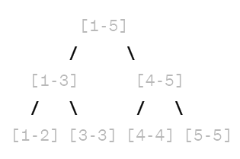

Here, each node stores the sum of elements within its corresponding range.

______________________________________________________________________

# Fenwick Tree (Binary Indexed Tree):

Description:

A Fenwick tree, also known as a Binary Indexed Tree (BIT), is a specialized data structure primarily used for computing prefix sums and efficiently answering range sum queries.

Space Complexity:

The space complexity of a Fenwick tree is O(n), where n is the number of elements in the input array. Similar to segment trees, Fenwick trees require additional space to store information for each element.

Building the Tree:

Constructing a Fenwick tree involves updating specific indices based on their binary representations. Each node in the tree represents a range of indices, and the value stored at a node represents the cumulative sum of elements up to that index.

Query Processing:

Querying a Fenwick tree involves traversing the tree from the leaf node corresponding to the queried index up to the root node. During traversal, the algorithm accumulates the sum of values stored at each node along the path, resulting in the final result.

## Example:

Suppose we have an array [1, 3, 5, 7, 9]. The Fenwick tree for this array would look like:

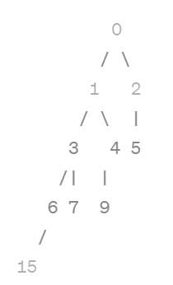

Here, each node stores the cumulative sum of elements up to that index.

______________________________________________________________________

# Sparse Table:

## Description:

Sparse table is a dynamic programming technique used to preprocess an array to efficiently answer static range queries. It achieves constant-time query processing by precomputing answers for all possible ranges using the concept of binary lifting.

Space Complexity:

The space complexity of a sparse table is O(n log n), where n is the number of elements in the input array. This is because the sparse table requires additional space to store precomputed values for each range.

Building the Table:

Constructing a sparse table involves filling in values using dynamic programming techniques. The table is built iteratively, where each entry [i][j] stores the result of the range query for the interval [i, i + 2^j - 1].

Query Processing:

Querying using a sparse table has a time complexity of O(1). This constant-time complexity is achieved by directly accessing precomputed values from the table. For a given range [l, r], the algorithm calculates the highest power of 2 (k) such that l + 2^k - 1 ≤ r. Then, it retrieves the precomputed result from the table at index [l][k].

Example:

Suppose we have an array [1, 3, 5, 7, 9]. The sparse table for this array would look like:

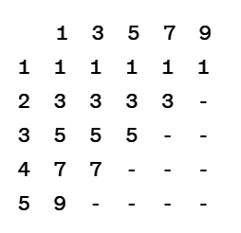

Here, each cell [i][j] stores the result of the range query for the interval [i, i + 2^j - 1].

______________________________________________________________________

# Segment Tree with Lazy Propagation:

Description:

A segment tree with lazy propagation is an extension of the basic segment tree that incorporates additional techniques to efficiently update ranges. It postpones updates until necessary to optimize query processing time.

Space Complexity:

The space complexity of a segment tree with lazy propagation is O(n), where n is the number of elements in the input array. Similar to a basic segment tree, additional space is required to store information for each segment.

Building the Tree:

Constructing a segment tree with lazy propagation has a time complexity of O(n). Building the tree involves recursively partitioning the array into smaller segments. Additionally, each node in the tree stores lazy update information.

Query Processing:

Processing a query using a segment tree with lazy propagation has a time complexity of O(log n). This is because querying involves traversing the tree's height. Before processing a query, the algorithm applies any pending updates lazily to the relevant segments.

Example:

Suppose we have an array [1, 3, 5, 7, 9]. The segment tree with lazy propagation for this array would look like:

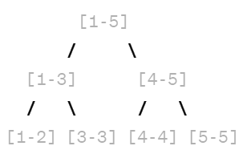

Here, each node stores the sum of elements within its corresponding range, along with lazy update information.

______________________________________________________________________

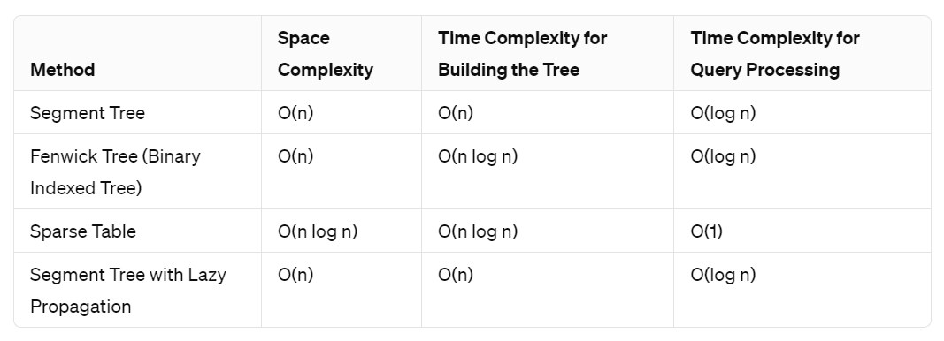

# Conclusion:

# Each range query technique discussed above offers unique advantages and is suitable for different problem scenarios. Understanding the principles, space, and time complexities of each technique is crucial for selecting the most appropriate solution based on the requirements of the problem at hand. Whether it's the versatility of segment trees, the efficiency of Fenwick trees, the constant-time query processing of sparse tables, or the dynamic capabilities of segment trees with lazy propagation, these techniques provide powerful tools for solving a wide range of range query problems efficiently.

______________________________________________________________________

### 

### **Name:** Chandana Ramesh Galgali

### **Roll No.:** 16010422234

### **Div:** B

### **Batch:** 4